FLASK APP DEPLOYMENT.

1. Launch AWS ec2 instance with t2 micro
2. Open ports for 8080 and 5000,80,443,22
3. Install docker ,jenkins,git,at
4. Write a docker file and app.py, requirements.txt (for dependencies)
5. Create git hub accesstocken
6. Create a repository in git with name flaskapp and push files to github repository
7. Set up webhook on repository
8. Configure jenkins and create a job by using jenkins file with enabling git hub webhook
9. Build the job.chk the output on {publicip:5000}

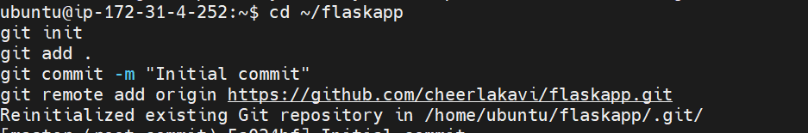

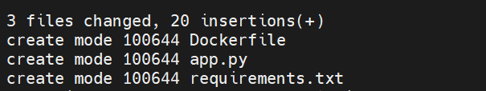

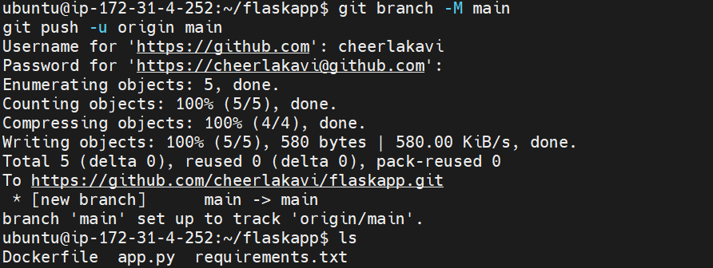

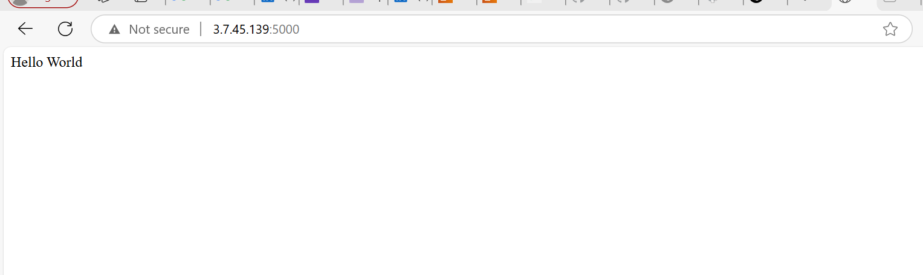

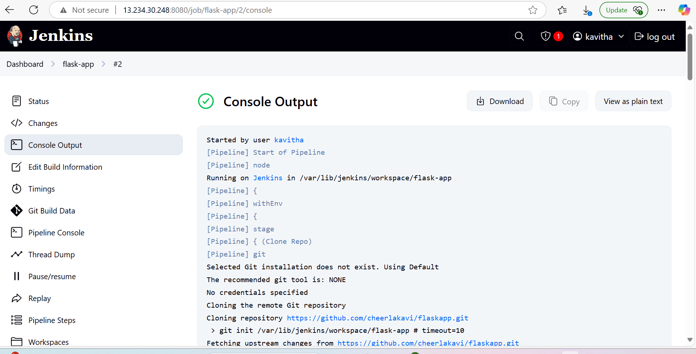

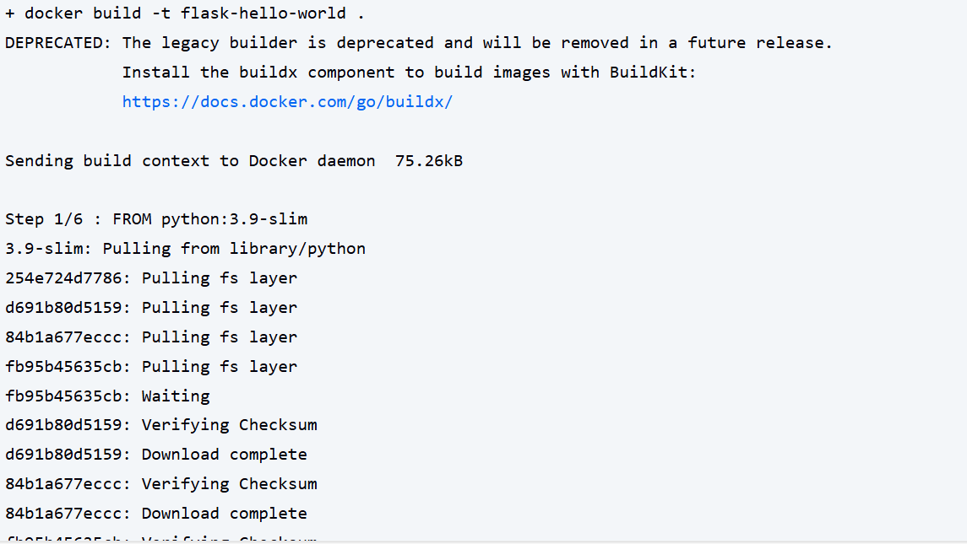

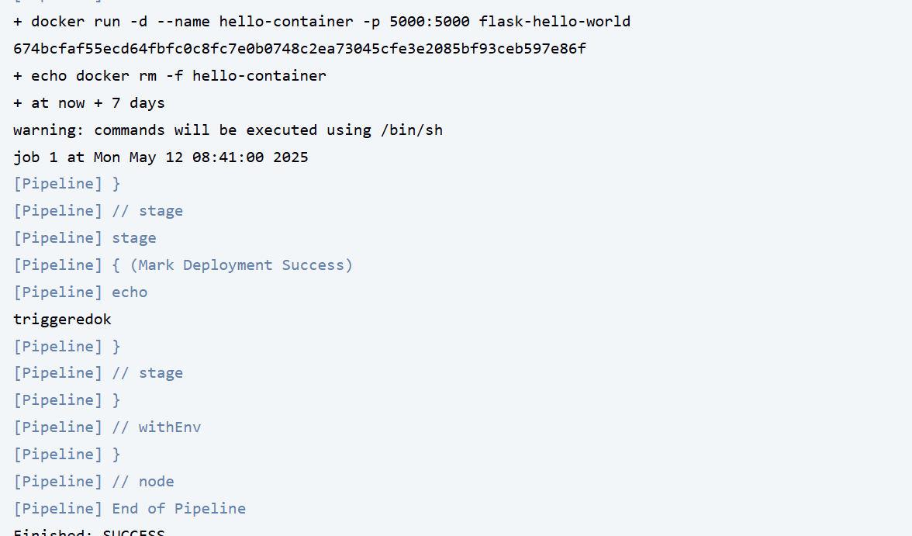



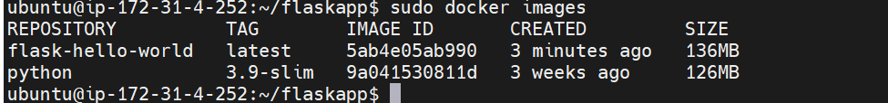

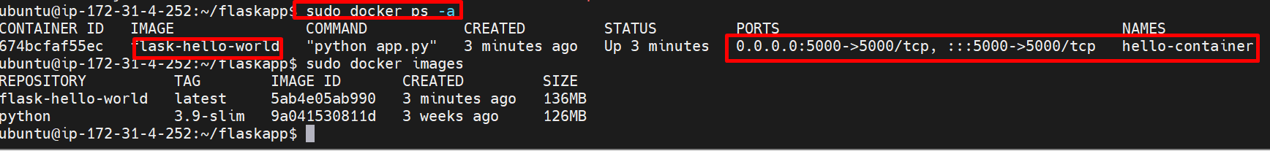

After doing commit

